Financial Analysis Repport of HUL
About the company
Hindustan Unilever is in the FMCG business comprising primarily of Home Care, Beauty & Personal Care and Foods & Refreshment segments. The Company has manufacturing facilities across the country and sells primarily in India. The company has a portfolio of over 50 brands, spanning 16 FMCG categories, including 19 brands with a turnover of more than Rs. 1,000 Cr PA.

Income statement analysis
Sales: 33,162 → 64,468
Net profit: 4,476 → 15,040
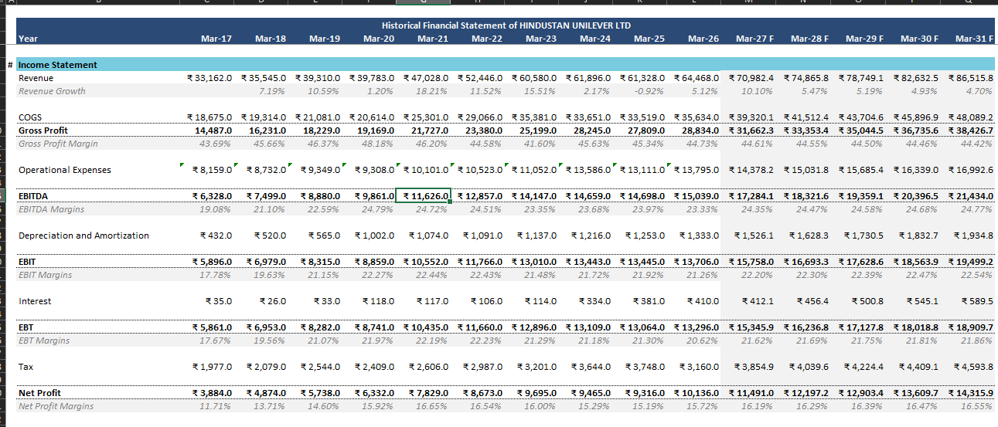
- Revenue growth:
  - Strong top-line expansion: Sales increased from ₹33,162 crore to ₹64,468 crore over the period, showing robust and consistent growth.
  - Resilience: Even in recent years, sales remained stable around ₹61,328–64,468 crore, indicating strong brand equity and demand stability.
- Cost structure and margins:
  - Raw material cost: Increased from ₹13,606 crore to ₹29,158 crore, broadly tracking revenue growth, suggesting stable gross margins.
  - Operating expenses: Employee cost, selling & admin, and other expenses have risen, but not disproportionately, indicating disciplined cost management.
  - Operating profit: Profit before tax rose from ₹6,467 crore to ₹18,219 crore, reflecting margin expansion and operating leverage.
- Profitability:
  - Net profit growth: Net profit increased from ₹4,476 crore to ₹15,040 crore, outpacing revenue growth and highlighting improved efficiency.
  - Other income impact: Other income jumped significantly in the latest year (₹4,923 crore), boosting overall profitability.
  - Tax burden: Tax expense remained relatively controlled versus profit before tax, supporting healthy net margins.
- Dividend policy:
  - Consistent payouts: Dividend amount rose from ₹3,672 crore to peaks like ₹12,455 crore, reflecting strong cash generation and shareholder-friendly capital allocation.

Balance sheet analysis
Equity Share Capital: 216 → 235
Reserves: 6,528 → 48,504
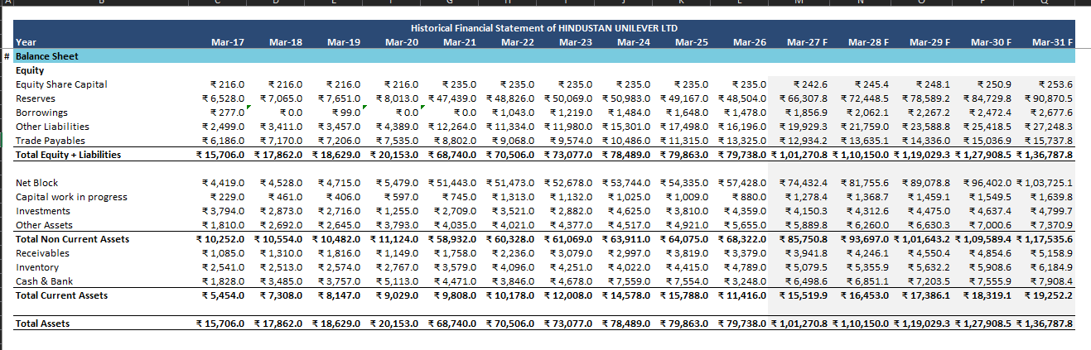
- Capital structure:
  - Equity base: Equity share capital increased slightly (bonus/issuance), while reserves surged from ₹6,528 crore to ~₹48,504 crore, indicating strong retained earnings.
  - Low leverage: Borrowings appear modest (e.g., ₹1,484–1,648 crore in mid-years), suggesting a conservative balance sheet with low financial risk.
- Asset composition:
  - Fixed assets: Net block rose from ₹4,419 crore to ₹57,428 crore, showing sustained investment in productive capacity and infrastructure.
  - Investments: Investments fluctuate (₹3,794 → ₹4,359 crore), indicating active portfolio management and strategic stakes.
  - Other assets: Other assets increased from ₹7,264 crore to ₹17,071 crore, reflecting growth in non-current and miscellaneous assets.
- Working capital and liquidity:
  - Receivables: Grew from ₹1,085 crore to ₹3,379 crore, broadly in line with sales, suggesting stable credit policy.
  - Inventory: Increased from ₹2,541 crore to ₹4,789 crore, consistent with scale-up but requiring monitoring for efficiency.
  - Cash & bank: Cash balances moved from ₹1,828 crore to ₹3,248 crore, with some volatility, but overall adequate liquidity.
- Overall balance sheet quality:
  - Strong equity cushion, low debt, and healthy asset base point to a robust financial position and high solvency.

Cash flow statement analysis
Cash from Operating Activity: 5,185 → 10,999
Free Cash Flow: 4,248 → 9,667
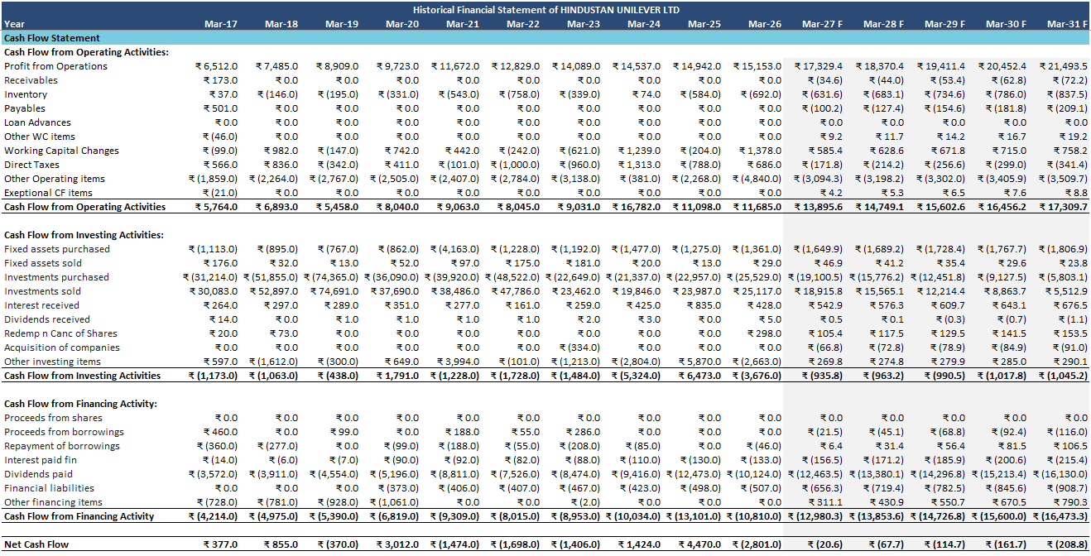
- Operating cash flows (CFO):
  - Consistent generation: CFO increased from ₹5,185 crore to ₹10,999 crore, broadly tracking profit growth and confirming earnings quality.
  - Working capital management: Working capital changes are mixed (e.g., -1,000, +1,313, -788, +686), but overall do not structurally impair cash generation.
- Investing cash flows (CFI):
  - Capex: Fixed assets purchased show regular investment (e.g., -₹1,113 to -₹1,361 crore), supporting long-term growth.
  - Investment activity: Large investment purchases and sales (e.g., -₹31,214 vs +₹30,083 crore) indicate active treasury and strategic investment management.
  - Net CFI: Alternates between outflows and inflows (e.g., -₹1,173, +₹1,791, +₹6,473, -₹3,676), reflecting timing of investments and divestments.
- Financing cash flows (CFF):
  - Dividends: Significant outflows from dividends (e.g., -₹3,572 → -₹10,124 crore) show strong shareholder returns.
  - Debt movements: Limited borrowing and repayments, consistent with low leverage strategy.
  - Net CFF: Persistent outflows (around -₹4,214 to -₹13,101 crore), driven mainly by dividends and modest debt repayments.
- Net cash flow and FCF:
  - Net cash flow: Volatile but generally manageable (e.g., -₹202, +₹2,595, +₹5,258, -₹3,487), indicating active capital allocation.
  - Free cash flow: Strong and rising (₹4,248 → ₹9,667 crore), underscoring HUL’s ability to fund growth and distributions internally.

Ratio analysis
Ratio Analysis: Gross Profit Margin, EBITDA Margin, Net Profit Margin, ROA, ROE, Debt/Equity, Current Ratio, P/E, etc.
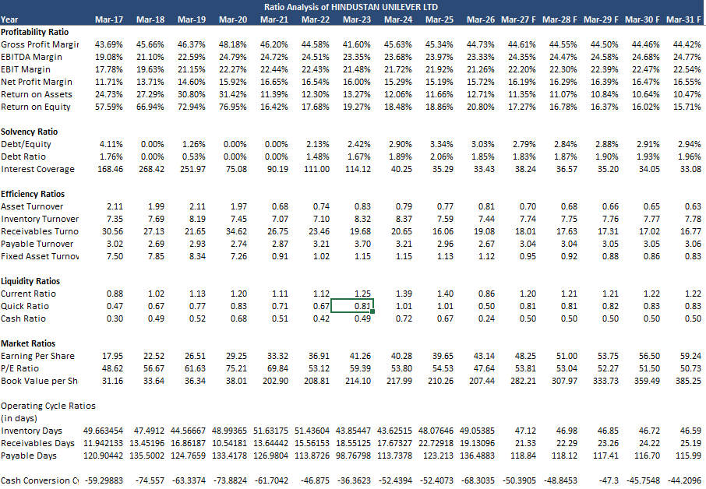
- Profitability ratios:
  - Gross & EBITDA margins: Given stable cost structure and rising profits, margins are likely strong and improving over time.
  - Net profit margin: Rising net profit faster than sales suggests margin expansion and better operational efficiency.
- Return ratios:
  - ROE: Large increase in reserves and high profitability imply strong return on equity, a key strength for HUL.
  - ROA: Growing assets with higher profits point to healthy asset productivity.
- Solvency ratios:
  - Debt/Equity & Debt ratio: Low borrowings relative to equity indicate conservative leverage and high solvency.
  - Interest coverage: Rising EBIT and modest interest expense suggest very comfortable interest coverage.
- Liquidity ratios:
  - Current & quick ratios: With solid receivables, inventory, and cash, short-term liquidity appears adequate to strong.
- Market ratios:
  - EPS & P/E: High valuation multiples (P/E) are typical for HUL, reflecting its defensive, high-quality earnings profile.
  - Book value per share: Rising reserves and stable share capital support increasing book value per share.

Trend analysis
Sales: 33,162 → 64,468
Net profit: 4,476 → 15,040
Cash from Operating Activity: 5,185 → 10,999
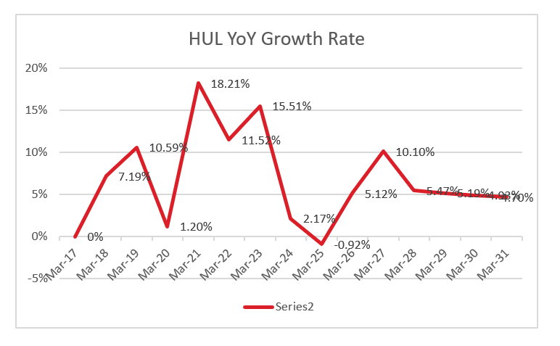
- Revenue trend:
  - Upward trajectory: Sales show a clear long-term uptrend, with no major structural decline, indicating sustained demand and market share.
  - Short-term fluctuations: Minor year-on-year variations are visible but remain within a narrow band, typical for a mature FMCG player.
- Profit trend:
  - Steady profit growth: Net profit has grown consistently, with a notable jump in the latest year, partly aided by higher other income.
  - Margin resilience: Profit growth outpacing sales suggests improving margins and operational efficiency.
- Cash flow trend:
  - CFO growth: Operating cash flows have increased broadly in line with profits, confirming that earnings are backed by cash.
  - FCF trend: Free cash flow shows a strong upward pattern, supporting ongoing dividends and reinvestment.
- Balance sheet trend:
  - Asset expansion: Net block and other assets have grown steadily, reflecting continuous investment in capacity and capabilities.
  - Equity build-up: Reserves have expanded significantly, indicating consistent retention of earnings.

Competitor analysis
Comp Analysis: Hindustan Unilever, ITC, Hindustan Foods, Godavari Bioref.
HUL Share Price: 2,135.8; Shares Outstanding: 234.96
- Peer set:
  - ITC: Large diversified conglomerate with significant FMCG, cigarettes, and other businesses.
  - Hindustan Foods & Godavari Bioref: Smaller players, more niche compared to HUL’s broad FMCG footprint.
- Relative scale:
  - HUL vs peers: HUL’s market cap and revenue base are substantially larger than Hindustan Foods and Godavari Bioref, and comparable to or higher than ITC’s FMCG segment.
  - Enterprise value metrics: The sheet is structured to compare EV/Revenue, EV/EBITDA, and P/E, indicating that HUL likely trades at a premium valuation versus peers due to brand strength and profitability.
- Valuation positioning:
  - Premium multiples: HUL’s higher P/E and EV/EBITDA relative to peers reflect its superior margins, cash flows, and defensive business model.
  - Implied value: The model aims to derive implied enterprise value and implied value per share, suggesting that HUL’s intrinsic value is benchmarked against peer multiples.

Overall assessment and conclusion
Net profit: 4,476 → 15,040
Free Cash Flow: 4,248 → 9,667
Reserves: 6,528 → 48,504
- Financial strength:
  - Robust profitability: Strong and rising revenues, expanding margins, and consistent net profit growth underline HUL’s high-quality earnings profile.
  - Healthy cash flows: Growing CFO and FCF support both reinvestment and generous dividends, reinforcing financial flexibility.
- Balance sheet quality:
  - Low leverage, high reserves, and substantial asset base make HUL a fundamentally sound and low-risk company.
  - Adequate liquidity and efficient working capital management further strengthen its financial resilience.
- Strategic outlook:
  - Sustained growth potential driven by rising consumption, premiumization, and innovation in product portfolio.
  - Key risks include input cost inflation, competitive intensity, and regulatory changes, but the company’s scale and execution capabilities provide strong mitigation.
- Conclusion:
  - Hindustan Unilever emerges as a financially robust, cash-rich, and highly profitable FMCG leader with strong long-term fundamentals.
  - For a long-term investor, HUL represents a high-quality, relatively low-risk compounder, albeit at a premium valuation that reflects its strengths.

